Porridge  With various toppings | 

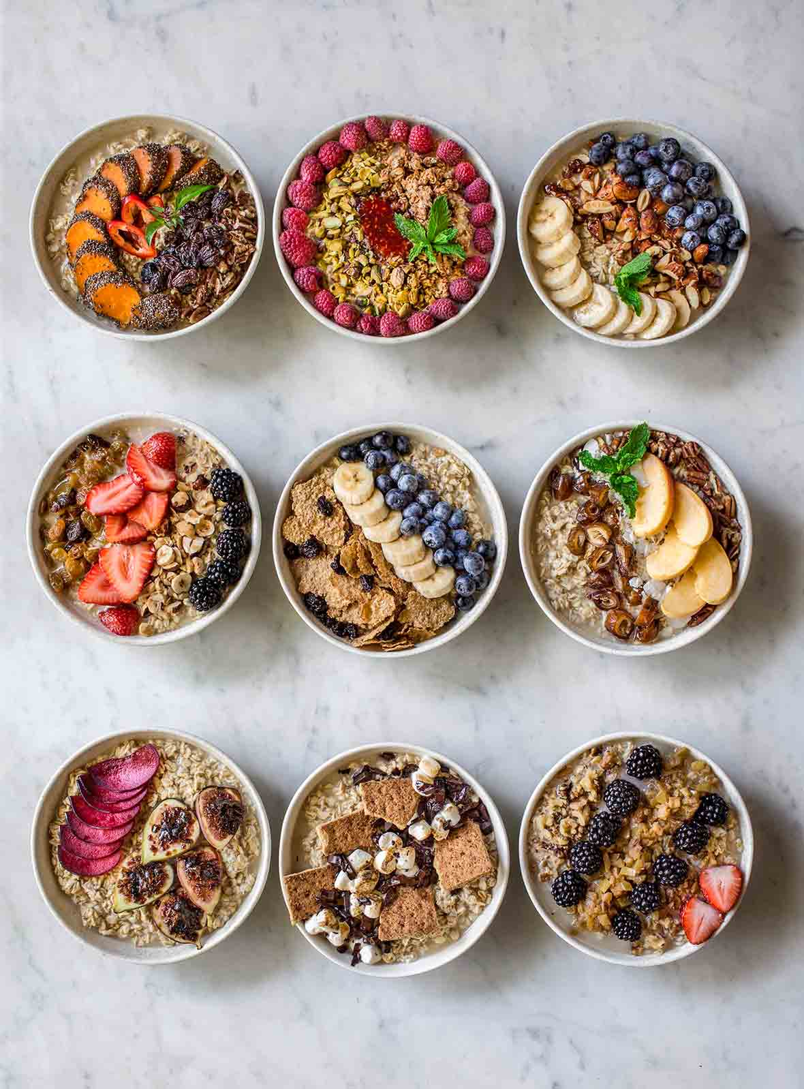 | Number of servings: 2  Prep time: 10 min  Cook time: 5min  Total time: 15 min  Cost: £0.18p per serving, plus toppings (£0.20p- £0.80p)
Porridge:
- 30g of Oats and 60ml water 60ml milk.
Topping Ideas:
- Banana and Cinnamon.  - Grated Apple and Pecan.  - Mango and Passionfruit.  - Carrot, Raisins, Cinnamon and Nutmeg.  - Grated Beetroot, Sultanas and Pecans.  - Figs, Cranberries and Almonds.  - Plums and Cinnamon.  - Chocolate and Hazelnuts..  - Pomegranate molasses and Feta. | - Peanut butter and Raspberries.  - Cacao and Coconut.  - Apple and Blackberry.  - Tahini, dates, poppy seeds.  - Vanilla and Ginger.  - Cacao and Avocado.  - Raspberries, Cardamom and Vanilla.  - Cranberries and Orange.  - Mixed seeds, Egg and Spinach.  - Cashews and Turmeric.

