**Poached egg on toast**

This quick breakfast dish is a great healthy choice. Unlike other egg dishes cooked in fat poached eggs are cooked in water, making them a healthier and cheaper option.

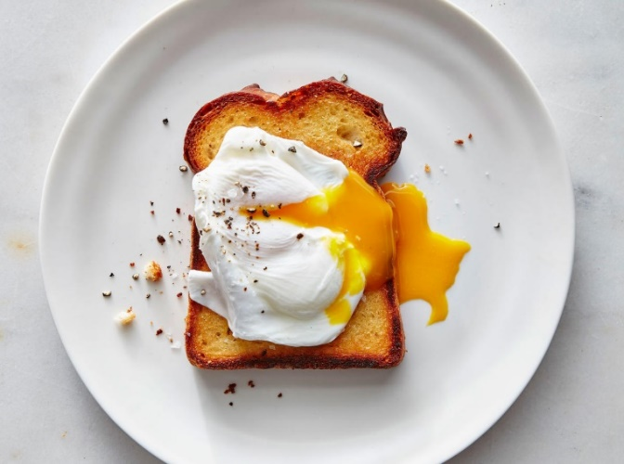

**Serves 1** (Cost: £.20 per serving)

**Ingredients**

* 2 Free range eggs
* 1 Piece of whole meal toast
* 1 Tbsp vinegar

**Method**

1. Put a sauce pan of water 5 inches deep onto the boil. While the water is boiling crack the egg into a small ramekin.
2. Once the water is boiling add the vinegar and reduce the heat to a low temperature. Using a whisk swirl the water in circles to make a tight whirl pool.
3. Gently pour the egg into the center of the whirl pool and leave to poach for 4 minutes or until set. While the eggs are cooking don’t forget to get the toast on.
4. Remove the egg from the pan using a slotted spoon, ensuring that it’s fully drained of water.
5. Place the eggs on top of the toast and enjoy.