**North and East Cornwall ICA**

**Liskeard and Looe Foodbank Project**

**Executive Summary**

As part of a channel shift of resource and health creation, North and East ICA are reviewing the impact of strong education around nutrition preparing meals and budgeting skills. As a focus area for the ICA is children and young people, as part of supporting future generations, the proposal is to provide fresh ingredients for families with young children accessing the foodbanks. Liskeard and Looe Foodbank as part of the Trussell Trust currently offer a meal plan scheme, with cooking tutorials and the ingredients required except for fresh ingredients. North and East ICA are therefore proposing to allocate funding through VSF to support the provision of fresh ingredients for the meal plans specifically for families with young children. As part of this test and learn the aim is to understand the benefits of families cooking and eating together, the overall result of education and support when meal planning and the impact this has on the wellbeing and outcomes for the children.

This test and learn will be run alongside a fruit and vegetable box pilot for diabetic patients, again by understanding the benefits to patients but also the potential cost savings, financial resource may then be allocated to supporting an expansion of the food bank meal plans. Finally, the overall aim would be for the fruit and vegetables to be obtained from community growers, ensuring financial support for local organisations, and allowing for a more sustainable model.

The ICA are looking to work in collaboration with The Liskeard and Looe Foodbank as they are a Pathfinders site, meaning any learning can be rolled out to other foodbanks. They are also partnered with Eccabi a charity providing training on money saving, personal budgets, and cooking lessons. The foodbank are also working closely with Home Start Kernow and the local schools.

Alongside this project Launceston Medical Centre are, with other PCNs across the county, piloting fruit and vegetable boxes as food on prescription for a cohort of diabetic patients. Learning will be shared and the aim is for research evaluation to be completed on the projects as a whole though the WellFed network, supported by Sustainable Food Cornwall and the Volunteer Cornwall Climate Resilience Team. The Wellfed network are bringing together a range of stakeholders that are establishing or completed similar projects, academics studying this area and community organisations. This partnership will collaborate to design evaluation methodology, report findings and share best practice and opportunities during and after the programmes of work.

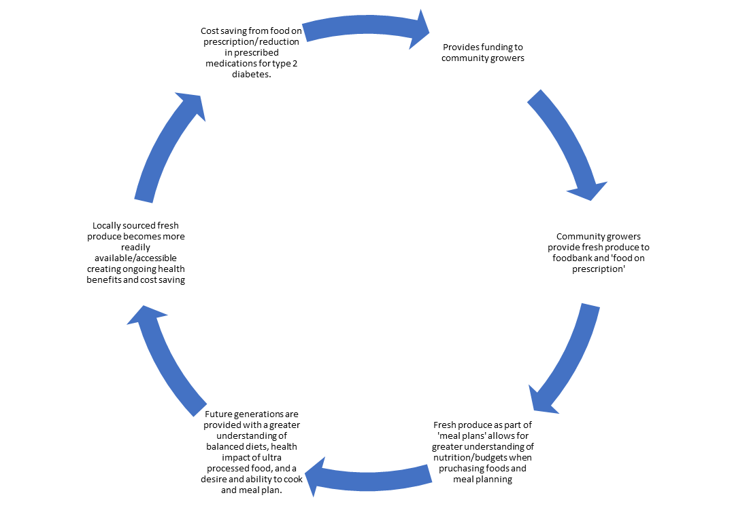

**Key stakeholders**

- Sustainable Food Cornwall

- Public Health

- GP practices/ PCNs

- VSF

- Academics

- The Lighthouse Centre, Liskeard

- Liskeard/Looe foodbank

During the test and learn stage community growers will not be involved but green spaces and how the scheme could work with community growers going forward will be considered throughout.

**The Project**

The proposal is for 96 families to be supported over the period of a year. This is broken down by delivering the programme to 8 families per cohort over a 5-week period, one session per week.

At the end of the five weeks the families will then be directed towards the community larder at The Lighthouse Centre where they can also access support services provided by the Integrated Health and Social Care Hub as well as the Community Hub. The cohorts will then be reviewed on a quarterly basis following on from their 5-week session for up to a year after their participation.

Further educational sessions will be provided seasonally to support the families with understanding how to respond to the seasonal change in vegetable availability. This will have two rotations of Autumn/Winter and Spring/Summer.

**Desired outcomes/ measurement**

The desired outcome is to support families to increase their consumption of fruit and vegetables over the time frame of a year and maintain this increase once they have completed the programme. A range of monitoring information will be collected including a comparison of well- being scores, an understanding of their reliance on either the foodbank or Community Larders and an understanding of their ongoing engagement with the education aspect of the programme over the year.

Other outcome measures will be considered and agreed with input from the stakeholders of the Health and Food working group and may include, but not limited to:

- School performance

- Improved engagement with health services

- Increased uptake of community services including volunteering

- Council tax arrears, benefits uptake, confidence in budgeting

- Measurement of cooking as a family, enjoyment of cooking etc.

A final set of measurements and report time frame will be generated prior to commencement of the programme and agreed by all stakeholders.