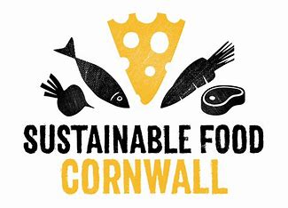WellFed Cornwall 2024

Active Project:

Newquay Health Centre

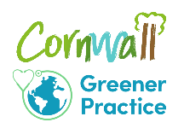WellFed Cornwall is an informal network of health professionals, community and small growers, and third sector organisations, supported by Sustainable Food Cornwall, and Volunteer Cornwall Climate and Health Resilience team. We are all working to improve access to good food for one and all as part of our provision of health CARE (ie as a means of treating sickness and reducing inequality), and equally as a means of achieving health CREATION (ie actively creating communities and initiatives which ensure everyone gets good food, can stay well, and avoid preventable disease). These brief Case Studies of active projects are this network’s way of moving our good practices and ideas around for all to share, so just share what you are happy to.

For more info, contact [mandab@volunteercornwall.org.uk](mailto:mandab@volunteercornwall.org.uk) or [claire@sustainablefoodcornwall.org.uk](mailto:claire@sustainablefoodcornwall.org.uk)

|  |
| --- |
| Practice and community grower |
| Newquay Health Centre (Mid ICA) with Newquay Storehouse |
| Main contact name and details |
| Emma Seward-Adams and Izzy Webb |
| Brief description of the aim of the project |
| This money will be spent on meal bags, recipe cards and cooking sessions. Each week two members of our team will demonstrate a cooking session to a maximum of 12 people. These 12 participants will then receive a meal bag with all the ingredients required plus a simple recipe with images. This will continue for 6 weeks, meaning we would demonstrate 6 recipes in total.  Total cost for ingredients at £6 per head = £432 Price for each session hire = £240 Total request = £672 |
| Monitoring and evaluation |
| Qualitative and quantitative feedback from the participants about the scheme once it finishes, especially around what recipes they liked/disliked. We would also make note of if any ingredients were disliked or wasted.  The Store House will be monitoring uptake of the vegetables it has from the Gleaning Network and whether demonstrating usage increases people choosing these items. Feedback from the staff who can refer to this scheme, to see how readily it was taken up by participants.  We will also work with the WellFed researchers at Universities of Bath and Cardiff as they develop a more detailed design brief over the summer, to enable further research. |